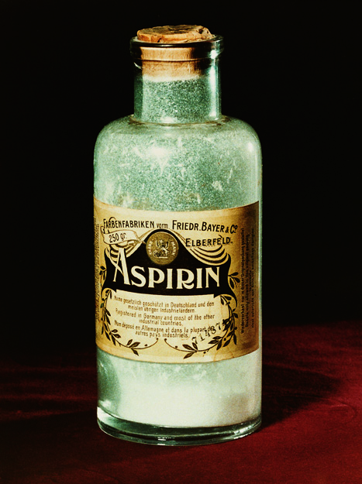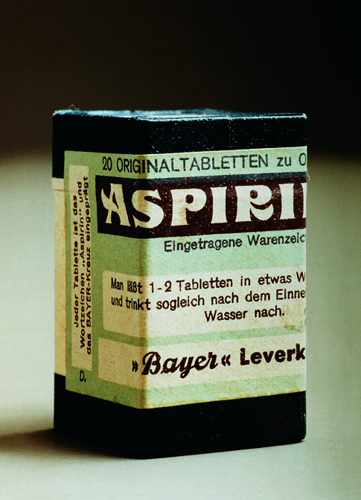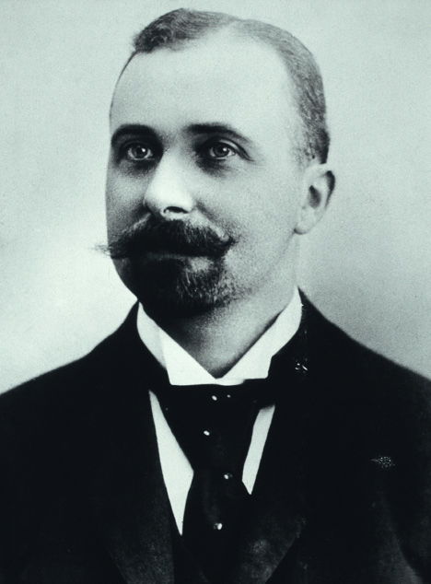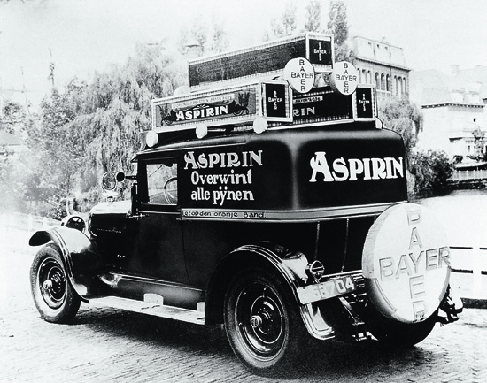

The History of Bayer Aspirin
With its more than 100 years of age, Aspirin® can look back at a rich, long-standing history and exciting future. Since its introduction, its effects have been recognized by the scientific community and consumers around the world. Aspirin reduces pain and fever and can reduce the risk of death if used during a suspected heart attack and 30 days thereafter. It is also prescribed to prevent heart attack and ischemic stroke in appropriate at-risk patients. Few drugs possess such a versatile therapeutic range as this Bayer drug.

The rich and continuously evolving story of Aspirin® began with a young Bayer chemist’s quest to ease his father’s pain. On August 10, 1897, Dr. Felix Hoffmann succeeded in synthesizing a chemically pure and stable form of acetylsalicylic acid for the first time in one of Bayer’s laboratories in Wuppertal, Germany. A new, multi-faceted analgesic was born and legend has it that it was immediately put to good use for the benefit of Hoffmann's father, who had suffered for many years from painful rheumatism. His doctors had previously prescribed sodium salicylate, a bitter-tasting medicine. Thanks to his son’s discovery, he was now able to relieve his symptoms with a more easily tolerated substance, acetylsalicylic acid, the active ingredient in Bayer’s Aspirin®. Since that time, tens of millions of people have turned to Aspirin® for effective pain relief.

During the early time after its discovery, however, the head of Bayer’s pharmacological laboratory, Professor Heinrich Dreser, was not particularly interested in this discovery. Even though doctors who tried the substance on their patients enthusiastically reported about the efficacy of the drug, he gave it little attention. When Bayer’s Managing Director, Carl Duisberg, insisted on testing the drug once more, the results convinced all, including Professor Dreser, of its value. In 1898, the first trial results were published and the beneficial pain-relieving effects of acetylsalicylic acid were described. This prompted the company to start production of the substance. On March 6, 1899, Bayer’s Aspirin® brand was registered under number 36433 in the list of trade names at the Imperial Patent Office in Berlin, Germany.

Bayer also registered patents for the name and manufacturing method both in England and the USA. England, however, rejected the patent application because in 1897, the German company “Chemische Fabrik von Heyden” had already registered aspirin under the brand name “Acetylin”. In the USA, Bayer received its patent in February 1900. Starting from then on, Aspirin® was produced and sold in the United States.

Aspirin® was first available only in pharmacies and sold in powder form, in bottles of 250 grams each. Many companies copied Aspirin® soon after. To distinguish Aspirin® from generics, Bayer developed a formula that could be pressed into tablet form. Aspirin® thus became one of the first medicines industrially produced as tablets. The tablets had the advantage of being firm on the outside but could be easily dissolved in water. In addition, the tablets allowed the definition of standardized doses, in contrast to weighing powders.
The compact and practical dosage form has made Aspirin® a versatile drug. Soon, physicians recommended it for treatment of headache, dental and body pain, and aches, as well as fever due to cold or flu. Soon after its introduction, Aspirin® became the world’s most popular pain reliever, affordable by practically everyone. With more than a century of clinical experience, Aspirin®, continues to be recognized today as a proven, trusted and cost-effective pain reliever and is well tolerated at OTC (over the counter) doses. Recent meta-analyses, include individual patient data or study-level population data from 145 clinical trials representing more than 32,000 patients and 20 years of research on such use. Collectively, their results reaffirm the overall gastrointestinal safety profile of acetylsalicylic acid in short-term treatment of mild to moderate pain, aches and fever due to cold or flu when used as directed, demonstrating a low incidence of minor gastrointestinal side effects and no drug-related serious adverse events.

While Aspirin® established itself as a proven pain reliever, its mode of action remained a mystery more than 70 years after Hoffman’s discovery. Even as late as 1966, The New York Times ran a story about aspirin entitled, “The Wonder Drug That Nobody Understands.” Then, in 1971, British pharmacologist Professor John Vane discovered that the anti-inflammatory properties of acetylsalicylic acid result from its ability to inhibit the body’s production of certain chemical mediators (prostaglandins) that promote inflammation and, therefore, cause pain. His research laid the foundation for further aspirin studies and made him a Nobel Prize winner in medicine a few years later. In 2004, Professor Derek W. Gilroy succeeded in elucidating a hitherto unknown mechanism of action of aspirin. His research demonstrated a biological effect, providing new insights into the mechanisms of action of acetylsalicylic acid in terms of inflammation as related to the production of nitric oxide (NO). Acetylsalicylic acid produces inflammation-inhibiting hormones known as lipoxins, which in turn form nitric oxide (NO) and increase the nitric oxide levels in the blood. When there is acute inflammation, nitric oxide regulates the transport of white blood cells to sites of infection and injury. If acetylsalicylic acid is taken, Gilroy found that it was easier for white blood cells to leave the blood system to fight infection or repair injuries to tissues. As a result, he found that skin warmth, redness, swelling, and pain were reduced.

In the 1980’s, Aspirin® began its second “career.” The pivotal Second International Study of Infarct Survival (ISIS-2) was published. It demonstrated the efficacy of aspirin (160 mg/day) for the treatment of acute myocardial infarction. Scientists learned through this trial that acetylsalicylic acid taken during a suspected heart attack and for 30 days thereafter can reduce the risk of death and damage to the heart muscle. In addition, published clinical studies, including the Antithrombotic Trialist Collaboration (ATTC) trial, demonstrated that low-dose acetylsalicylic acid can prevent a heart attack in appropriate at-risk patients. This ground-breaking discovery and subsequent research has made aspirin the gold standard in secondary heart attack prevention today. It has also led to approval of Aspirin® in more than 50 countries for the prevention of a first heart attack or ischemic stroke (primary prevention) in appropriate patients. Today, aspirin continues to be supported and reinforced by the global scientific community through multiple international and national medical guidelines recommending its use in appropriate at-risk patients for prevention of cardiovascular events in both the primary and secondary settings.⁶,,, In terms of safety, when used as directed for its approved cardiovascular indications, aspirin is well tolerated and effective, and, for the vast majority of patients, is infrequently associated with clinically relevant side effects. Patients should work with their doctors to best determine if they are appropriate candidates for aspirin therapy. Bayer supports the use of Aspirin® for primary prevention of cardiovascular events in patients at appropriate risk only where there are approved indications.

Because of its remarkable history, Aspirin® has found its way into museums that include the Smithsonian Institution’s National Museum of American History in Washington, DC, USA. However, at the same time, it continues to play a key role in modern research. Every year, acetylsalicylic acid is the subject of an estimated 700-1,500 published scientific studies.

Experts agree that the drug continues to surprise and amaze scientists engaged in modern pharmaceutical research around the world. Building upon more than 200 clinical studies involving more than 200,000 patients on the cardiovascular and pain relief effects of acetylsalicylic acid, researchers in countries around the world continue to explore the potential benefits of aspirin across other disease states. Researchers are excited by the promise aspirin has shown so far in potentially helping to prevent, treat, or manage other chronic conditions and diseases. Bayer HealthCare is committed to continuing to work with the scientific community to maximize the utility of Aspirin® in appropriate patients as scientific support evolves. Bayer supports numerous studies evaluating the potential of Aspirin® to address unmet health needs. Additionally, Bayer provides education and supports charitable organizations that encourage patient/physician dialogue about cardiovascular disease risk and management.

Forward-Looking Statements
This release may contain forward-looking statements based on current assumptions and forecasts made by Bayer Group or subgroup management. Various known and unknown risks, uncertainties and other factors could lead to material differences between the actual future results, financial situation, development or performance of the company and the estimates given here. These factors include those discussed in Bayer’s public reports which are available on the Bayer website at www.bayer.com. The company assumes no liability whatsoever to update these forward-looking statements or to conform them to future events or developments.

Bayer AG, Consumer Care. 100 Years Aspirin. The unparalleled career of Aspirin. Leverkusen: Bayer AG; 1997.
Lanas A, McCarthy D, Voelker M et al. Short-term acetylsalicylic acid (aspirin) use for pain, fever, or colds – ..gastrointestinal adverse effects: a meta-analysis of randomized clinical trials. Drugs R D 2011;11(3):277–288.
Baron JA, Senn S, Voelker M et al. Gastrointestinal Adverse Effects of Short term Aspirin use: A Meta-analysis of Published Randomized Controlled Trials. Drugs in R&D 2013;13(1):9–16.
Paul-Clark MJ, Van Cao T, Moradi-Bidhendi N et al. 15-epi-lipoxin A4-mediated induction of nitric oxide explains how aspirin inhibits acute inflammation. J Exp Med 2004;200(1):69–78.
ISIS-2 (Second International Study of Infarct Survival) Collaborative Group. Randomised trial of intravenous streptokinase, oral aspirin, both, or neither among 17,187 cases of suspected acute myocardial infarction: ISIS-2. Lancet 1988;2(8607):349–360.
Antithrombotic Trialists’ (ATT) Collaboration. Aspirin in the primary and secondary prevention of vascular disease: collaborative meta-analysis of individual participant data from randomised clinical trials. Lancet 2009;373:1849–1860.
American College of Cardiology. Secondary Prevention and Risk Reduction Therapy for Patients With Coronary and other Atherosclerotic Vascular Disease: 2011 Update. Circulation 2011;124:2458–2473.
World Heart Federation. World Heart Federation Welcomes New Guidelines Providing Recommendations to Prevent Heart Attacks and Stroke. Press statement [Internet]. 2011 Nov 3 [cited 2013 Feb 25] Available from: http://www.world-heart-federation.org/press/releases/detail/article/world-heart-federation-welcomes-new-guidelines-providing-recommendations-to-prevent-heart-attacks-an/
European Society of Cardiology: European Guidelines on cardiovascular disease prevention in clinical practice (version 2012). Eur Heart J 2012;33:1635–1701.

